Part 1: Moths

Identify the difference between a moth and a butterfly
Moth | Butterfly

Identify at least two harmful moths and explain why/how they are harmful.
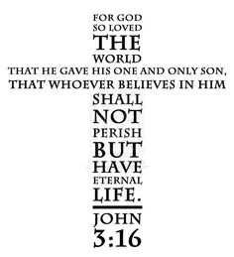
Write Matthew 6:19 in the shape of a butterfly. You may use the attached template.
This is an example of a Bible verse written in the shape of a cross.

How does this very connect to what you have learned about moths and butterflies?

How can this verse apply to your life?

Part 2: Butterflies

What causes colored powder to come off on your hands when you handle the wings?

Explain the lifecycle of a butterfly.

Identify three different cocoons or chrysalises.
What is a cocoon or chrysalis?

1. | 2. | 3.

Explain the migration patterns of the Monarch butterfly.
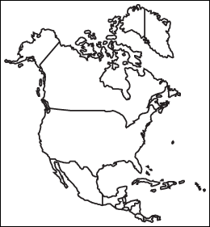

Part 3: Spiritual Significance

What Christian lesson can be learned in connection with the lifecycle of a butterfly?

Part 4: Projects

Project 1
Collect, Photograph, or Draw at least 10 species of moths and butterflies. Be able identify and to tell three facts about each species.

Project 2
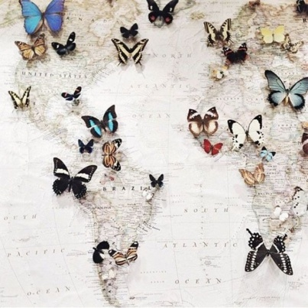
- Option A: On a world map, identify (with pins) the original location of at least 10 species of moths and butterflies. Put a tag on each pin with notes about each species. Attach a picture, drawing, or model.

(Use https://www.zeemaps.com/)

- Option B: Design the floor plan of a garden that would attract butterflies. Note the types of plants, colors, spaces, gardening techniques, etc. that would need to be used.

(Use http://www.smallblueprinter.com/garden/planner.html)

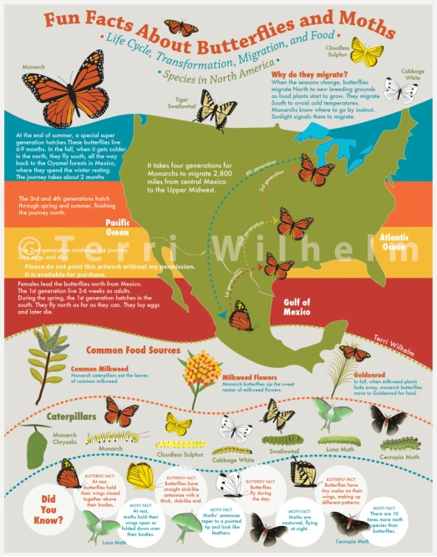

- Option C: Create a colorful info graphic about moths and butterflies. Incorporate at least 80% of the information you learned in this honor.

(Use Piktochart.com)
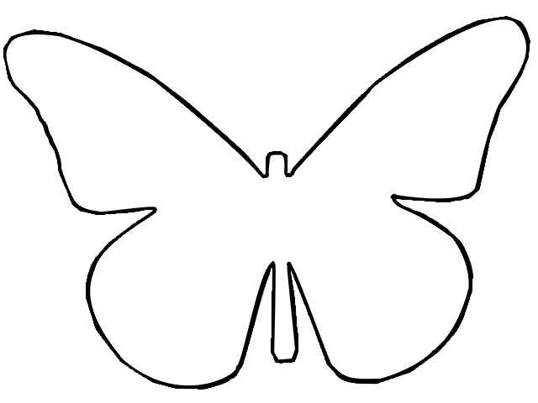
Butterfly Template for Part 1 Bible Verse
Suggestion for Instructors:

For a more active and self-guided approach, divide the requirements into stations. Pathfinders can rotate between the stations at their convenience. Pathfinders take learning into their own hands as they research, interact, collaborate, and find answers on their own. The instructor can easily monitor the class in this arrangement.

Station 1
Station 2
Station 3
Station 4
Station 5
Station 6
Whole Group

Moths vs. Butterflies Spiritual Significance Butterfly Bodies
Cocoon vs. Chrysalis

Butterfly Life Cycle Monarch Butterflies Cocoon vs. Chrysalis

Station Notes:
- Whole Group Area: Pathfinders can work on their projects or butterfly collections for Part 4 in this area.
- Station 2: Have bibles & copies of the butterfly template ready. Have markers, crayons, or colored pencils available for those who want to be creative.
- For the other stations, have books and tablets/laptops available to help students conduct research to answer the questions.
- Go to www.keepcalmandpathfinderon.weebly.com Honors Moths & Butterflies for videos, links, and even a butterfly life cycle game that can be helpful.

Recommendations:
For the butterfly collection, purchase Coloring Butterflies: 40 Delightful Pictures with Full Coloring Guides.

